Brainstorm & Idea Prioritization Template
Date | 03 Nov 2025
Team ID | NM2025TMID04510
Project Name | Calculating Family Expenses Using ServiceNow
Maximum Marks | 4 Marks

Phase of Ideation
Idea Prioritization and Brainstorming
This guided project shows how to use ServiceNow to create an all-inclusive family expense management system. Setting up a ServiceNow developer instance and generating update sets to handle configurations is the first step. To record aggregated and individual spending data, respectively, two main tables are created: Family Expenses and Daily Expenses. Data integrity and user-friendliness are guaranteed by auto-numbering and form customization.
To ensure precise and timely updates, relationships and business rules are used to automate the computation of total family spending based on daily submissions. Refining query logic to show linked daily spending beneath each family expense record for clarity is another step in the workflow.
This initiative helps families effectively manage their finances, encourages transparency, and supports well-informed financial decisions by automating the recording and classification of expenses.
This approach demonstrates the power of ServiceNow to streamline financial management processes within a family unit while reducing manual effort and errors.

Step-1: Team Gathering, Collaboration and Select the Problem Statement:
Enable families to efficiently track, categorize, and analyze their spending using a ServiceNow-based expense management system. The solution should support automated calculations, categorization, and reporting for both total and individual expenses.
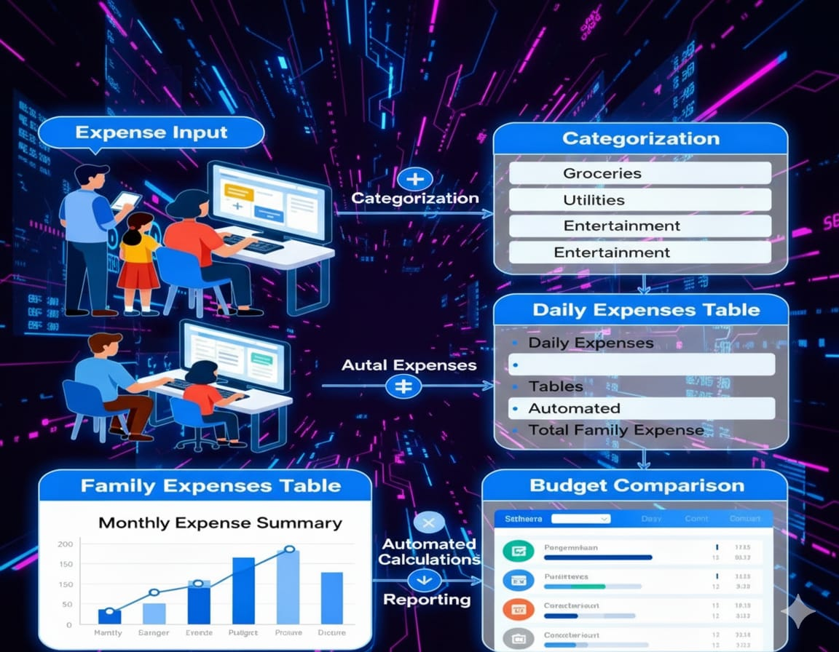

Step-2: Brainstorm, Idea Listing and Grouping
Getting Together as a Team
The group collaborated to choose the problem description, exchange concepts, and decide on system features. Idea Listing and Brainstorming
Create tables to keep track of daily and family spending.
Automate the daily computation of overall expenses.
Sort expenses into categories and connect them.
For record administration, use auto-numbering and upkeep.
Under each family spending record, show corresponding daily expenses.
Put business rules into practice for automation.
Make forms that are easy to understand and use.
Action Planning and Grouping
Concepts were categorized into: • Design and development of tables
• Automation (business rules) • Relational design (connecting daily and family spending) • Timelines and actions allocated for each step.
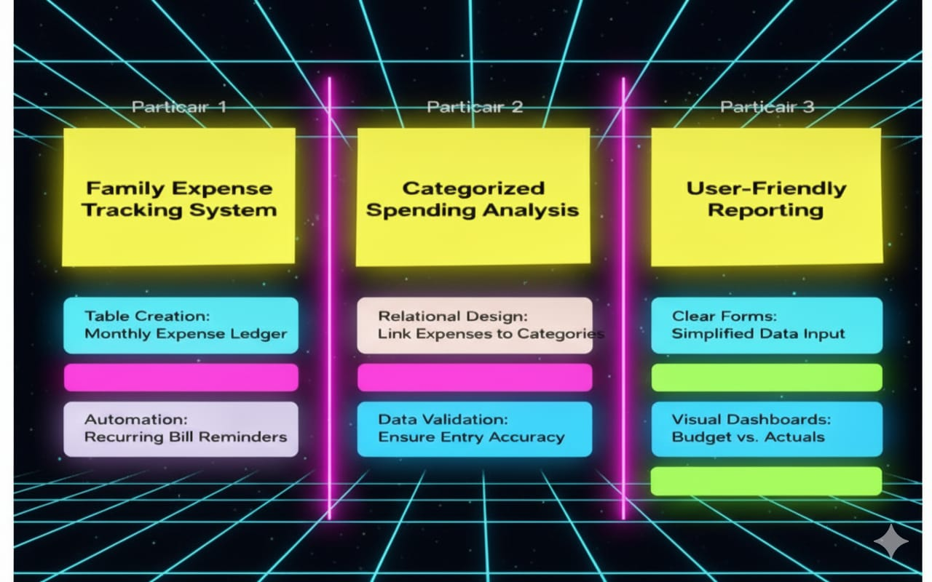

3. Setting Priorities for Ideas
Make automating daily cost totals a top priority.
Make sure fields are validated and forms are simple to use.
For reporting and clarity, concentrate on connecting records.
Make use of diagrams to illustrate

